SOFTWARE REQUIREMENT SPECIFICATION

FOR

*EXAM CELL*

*Version 1.0 approved*

*Prepared by*

*RM.RAMA CHIDAMBARAM*

*ORGANIZATION: NIIT UNVIERSITY.*

*DATE: 20/09/2016*

Table of Contents

Table of Contents 2

Revision History 2

1. Introduction 3

1.1 Purpose 1

1.2 Document Conventions 1

1.3 Intended Audience and Reading Suggestions 1

1.4 Product Scope 1

1.5 References 1

2. Overall Description 3

2.1 Product Perspective 3

2.2 Product Functions 3

2.3 User Classes and Characteristics 4

2.4 Operating Environment 5

2.5 Design and Implementation Constraints 5

2.6 User Documentation 5

2.7 Assumptions and Dependencies 5

3. External Interface Requirements 6

3.1 User Interfaces 6

3.2 Hardware Interfaces 6

3.3 Software Interfaces 6

3.4 Communications Interfaces 8

**4. System Features** 8

Use class diagram 8

4.1 Exam scheduling 9

4.2 invigilation scheduling 9

4.3 seating allotment 9

4.4 Distributed Database 9

**5. Other Nonfunctional Requirements** 10

5.1 Performance Requirements 10

5.2 Safety Requirements 10

5.3 Security Requirements 11

5.4 Software Quality Attributes 11

5.5 Business Rules 11

6. Other Requirements 12

Appendix A: Glossary 12

Appendix B: Analysis Models 12

Appendix C: To Be Determined List 12

Revision History

|  |  |  |  |
| --- | --- | --- | --- |
| **Name** | **Date** | **Reason For Changes** | **Version** |
|  |  |  |  |
|  |  |  |  |

# INTRODUCTION:

*We are planned to develop a web application to help the examination cell of our college.*

## 1.1 Purpose

This SRS document describes the requirements & functions of our Exam-cell system. It also explains the hardware and software interfaces used by us to develop this Web App.This SRS is intended for our customer (Exam-cell of NIIT University).

## 1.2 Document Conventions

*In this document, we are using the Normal font and heading is of size 16, sub heading is of size 13 and the remaining text size is 12.we use bold fonts wherever we require and normal font’s italics.*

## 1.3 Intended Audience and Reading Suggestions

*The intended audiences of this document are the software engineers. The document should be read step wise. The whole document has relation with something in the previous sections and so read the whole document systematically.*

## 1.4 Product Scope

*“The goal is basically to provide the exam cell with an easy, portable solution for preparing the seating allotment. “*

*The examination cell system will allow the examination cell to easily create the invigilation chart, seating allotment and exam schedule by just entering the basic details. It would greatly save the time of the department as till now they have been doing it manually which increases the chances of errors in the work. Further, the program provides details to the students and faculty members their individual details and not the whole chart which avoids confusion.*

## 1.5 References

* The reference used was the IEEE STD 830-1998 IEEE Recommended Practice for Software Requirements Specifications.
* https://www.academia.edu/7760318/STUDENTS_ATTENDANCE_MANAGEMENT_SYSTEM_MINI_PROJECT_REPORT_MASTER_OF_COMPUTER_APPLICATIONS
* http://krazytech.com/projects/sample-software-requirements-specificationsrs-report-airline-database

# OVERALL DESCRIPTION:

## Product Perspective

*Our Examination-cell web application is a new, independent self-contained product. As our University’s exam-cell is making examination schedule, Invigilation schedule, seating allotment manually with lots of effort. But the output they are giving to faculty and students is not user friendly and also they are not able to add more features to it. So our web app is very helpful for the Exam cell as it automatically generates the Exam schedule, Invigilation schedule, seating allotment. It gives user friendly output to Students and faculty and also we can add more features and the functions ,special features of our app is mentioned in product functions.*

## 2.2 Product Functions

*Major functions performed by our web app:*

* *Automatically generates the Invigilation schedule and every faculty or staff will be able to see their respective Invigilation schedule.*
* *Automatically generates the seating allotment and every student will be able to see their respective allotment.*
* *Automatically generates the attendance sheet of students who are allotted in respective class room.*
* *Sends email to the particular student or faculty with his or her own allotment only without showing any other persons allotment.*

***Additional features of our app:***

* *Online exam will be held before pen-paper.*
* *Students who are having less than 75% attendance in particular subject will not be seated or allotted room for exam.*
* *Faculty and staff who are on leave on a particular day will not be allotted for invigilation duty.*

## User Classes and Characteristics

**Exam-cell (Admin):**

There will be just one admin who will be responsible for maintaining the data on our software. The major access will be on his hands. He will be required to give the input of the subjects which are there for the examination chart preparation. The faculty who will be there in campus for the invigilation duty preparation. The list of all the students will be an input from his side for preparing their seating allotment. All the data can be stored in a database and will be fetched from there, but addition of a new faculty or other such factors will have to be maintained by the admin. Exam-cell is the primary user of our web app.

## 

## 2.4 Operating Environment

As our system is a Web application, it will be operated in any operating system including windows, Linux, iOS, android and will be compatible for all web browsers of all versions which supports CGI, Asp.net, php, HTML, angular JS.

Software components:

IDE: Visual studio 2015 enterprise

Cloud server: Microsoft Azure cloud

Database: Microsoft Azure storage explorer.

## 

## 2.5 Design and Implementation Constraints

Some implementation and design constraints of our system are:

* There is a time limit constraint as we have to submit our project within 2 months from now.
* There are no memory constraints.
* There can be a security constraint but we are trying to overcome this by using a hashing algorithm to encrypt the user data.

## 2.6 User Documentation

*We will provide the online as well as hard copy of the user manual to our customer which includes the instructions of how to use our web app.But for the users of our web app,there is no need of any manual as our product is self-explanatory*

## 

## 2.7 Assumptions and Dependencies

**Assumptions:**

* As the app will directly get the details of attendance of an individual student from the Nucleus of our University, we assume that a student who has less than 75% attendance will be debarred and will not be allowed to write the Examination. But he/she may get permission from the dean academics later to write the exam. But our app will not display the seating allotment of that particular student.
* We also assume that a particular faculty will inform when they want to take a leave. But in emergency, they may not inform. In such case, we will allocate the invigilation duty for that particular faculty.

**Dependencies:**

1. Our web app is dependent on our University nucleus.so, if we are not able to fetch the correct data from the nucleus, our app fails to work.

* If something goes wrong in our shuffling algorithm, our app will not be able to give the correct output.

3. EXTERNAL INTERFACE REQUIREMENTS:

## 3.1USER INTERFACE:

*IDE: Visual studio 2015 enterprise.*

*Back end software: Microsoft azure storage explorer.*

*Cloud platform: Microsoft azure.*

*Algorithm: Shuffling algorithm.*

## 3.2 HARDWARE INTERFACE:

*Any operating system.*

*Browser which supports CGI, Web app, JavaScript, HTML5, Asp.net.*

## 3.3 SOFTWARE INTERFACE:

|  |  |
| --- | --- |
| *OS* | *Windows 10 pro (for the best support of Visual studio 2015 enterprise)as it has a developer mode which is designed for developing purpose and it also supports high level software’s for developing purpose.* |
| *IDE(Integrated development environment)* | *Visual studio 2015 enterprise is the best platform for developing web app in (asp.net). It makes easy for developers to host the web app to Microsoft azure cloud.* |
| *Cloud server* | *Microsoft Azure. Our web app will be hosted in Microsoft azure cloud as it can handle million hits per second and it is easy to work in azure than compare to other cloud servers.* |
| *Database* | *Microsoft azure storage explorer as it is easy to create database and also compatible to connect with Microsoft azure cloud server.* |
| *Asp.net* | *It is an open source web framework for building modern web applications and services and another reason for choosing this is we use more tools from Microsoft for this software.* |
| *HTML5 and CSS* | *We use this two common languages to develop the frontend and styling for the web app.* |
| *Algorithm* | *Shuffling algorithm is used to make seating allotment for the students and invigilation duty for the faculties.* |

## 

## COMMUNICATION INTERFACE:

* *This web app will be supported by all types of browsers.*
* *It will communicate with the server to send e-mail to the particular person or group.*
* *The communication between the web app and the database is done by azure cloud server.*
* *The communication standards will be HTTP.*
* *The app will fetch the data from different tables of the database hosted in cloud server, then place them in a single table and at last they are displayed in the output page by a random order which is done by shuffling algorithm.*
* *The app include electronic forms for student details such as Enrollment no, Name, Section, Batch, Department, Subjects.*
* *It also include electronic forms for faculties detail such as Name, Subject handling.*
* *Password encryption for login with sha1 or md5 as they are one way encryptions.*
* *SQL injections will be prevented by type safe SQL command parameters.*

# SYSTEM FEATURES:

## Use case diagram:

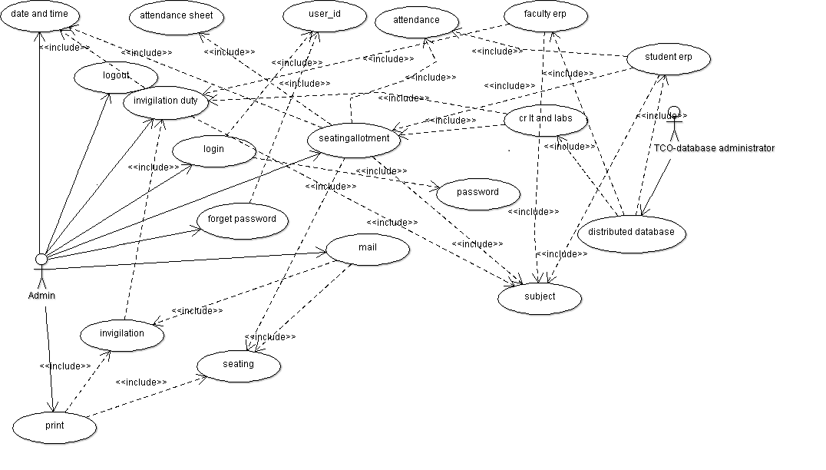

## 4.1 Exam Scheduling

## 4.1.1 Description and Priority

*The schedule of the exam will be generated by using the following function.*

* *It will be fetching details from database of how many subjects are there. Then the admin user will be providing the date and time between which we want to schedule our exams and this function will automatically generate an optimized form of the exam schedule so that their won’t be any overlaps of students having two exams at same time and date in which they are enrolled.*
* *The priority of this function will be high as we need an optimized and highly efficient result for the same.*

## 4.1.2 Stimulus

*Stimulus: The admin user logins.*

*Response: A page showing various features is displayed.*

*Stimulus: Examination scheduling selected there.*

*Response: A page showing enter time and date appears.*

*Stimulus: Enter the details and click on next.*

*Response: Navigates to the next page as a result.*

## 4.1.3 Functional Requirements

*We will see a page wherein we have to enter time and date as we want of the exams schedule and then when next button is pressed navigates to next page having buttons invigilation scheduling and seating allotment.*

## 4.2: Invigilation Scheduling

## 4.2.1 Description and Priority

* *The schedule of the invigilators will be generated by using this function. It will be fetching details from database as to how many invigilators are there and producing a result as to where there duty is.*
* *The priority of this function will be high as we need an optimized and highly efficient result for the same.*

## 4.2.2 Stimulus

*Stimulus: The admin logins.*

*Response: A page showing enter time and date appears.*

*Stimulus: Enter the details and click on next.*

*Response: Navigates to the next page as a result.*

*Response: A page showing various features is displayed.*

*Stimulus: Invigilation scheduling is selected there.*

*Response: A page showing available faculties.*

*Stimulus: click on allot.*

*Response: An invigilation duty sheet is presented as the result. Can be printed as well as save and sent through mails to the invigilators with only his or her allotment detail.*

## 4.2.3 Functional Requirements

*We will see a page where we have to click on allot button for the creation of the invigilation duty sheet. After creation two more buttons will be available. One will be print and the other one will be send*.

## 4.3: Seating Allotment

## 4.2.1 Description and Priority

* *The seating allotment of students will be generated by using this function. It will be fetching details from database as to how many students are enrolled in a subject and then depending on the rooms and labs available their seating allotment is produced.*
* *The priority of this function will be high as we need an optimized and highly efficient result for the same.*

## 4.2.2 Stimulus

*Stimulus: The admin logins*

*Response: A page showing enter time and date appears.*

*Stimulus: Enter the details and click on next.*

*Response: Navigates to the next page as a result.*

*Response: A page showing various features is displayed.*

*Stimulus: Seating allotment is selected there.*

*Response: A page showing student details.*

*Stimulus: click on allot.*

*Response: A seating allotment sheet is presented as the result. It can be printed or sent through mails to students with only his or her allotment detail.*

## 4.2.3 Functional Requirements

*We will see a page wherein we have click on allot button for the seating allotment sheet. After allotting two more buttons will be available. One will be print, other one will be send the attendance sheet will be prepared by clicking the print button.*

## 4.4: Distributed database:

Distributed database implies that a single application should be able to operate transparently on data that is spread across a variety of different databases and connected by a communication network *.In this project we are going to access three different database of NIIT University*

* + - *NU Student ERP*
    - *NU Faculty ERP*
    - *NU CR’S, LAB’S and LT”S*

# 5. Other Nonfunctional Requirements

## 5.1 Performance Requirements

* *The software will be showing only the names of the students who are not debarred in the seating allotment plan which will be sent to the students.*
* *The software will help in organizing the exam schedule in such a way such that no students enrolled in different subjects have a clash in their time table. Moreover the pen paper exams will be scheduled before the online exams.*
* *The invigilation sheet will take care of the fact that there is even distribution of duties among the professors. At times they will have their duty in class rooms and at times in lecture halls.*

## 5.2 Safety Requirements

As we have mentioned earlier that the server will be created on the basis of Microsoft azure. They also maintain a facility for the backup options such that our data can be regained back if our built server is corrupted. We will also provide a certified safety once it is implemented to real world.

## 5.3 Security Requirements

*Only the admin will be able to edit the database of the software. In order to enter into the software user has to enter his credentials which will be unique and it will be only given to the admin user of the software. The data’s that are given by the admin user will be encrypted by one way encryption method such as sha1 or md5 and type safe SQL parameter commands will be used so that the SQL injections will be prevented.*

## 5.4 Software Quality Attributes

***Availability****: The software will be made available to the admin of the exam cell department.*

***Reliability****: We will achieve the reliability of the system by manipulation of the database.*

***Reusability****: The software will be used by the exam cell at any time for seating allotment for exams.*

***Robustness:*** *If the computer stops functioning while creating the seating allotment then we can restart it or open it somewhere else.*

***Updatability:*** *The database used in the software can be updated. Delete and addition of new information can be done by the administrators of that particular database as we use distributed database.*

***Usability****: The usability of the software will be achieved by a user manual.*

## 5.5 Business Rules

The role of the web application is to automatically obtain the seating allotment of students and invigilation for faculty. This all can be obtained by single click from the admin user.

# 6. OTHER REQUIREMENTS:

## 6.1 Database requirement:

* *The software shall include 3 databases – The student, faculty/staff and the list of rooms and labs.*
* *All the database will have various fields distinguishing them from each other.*

# Appendix A: Glossary

*There are many terms used in our project which can be understood well by reading this.*

* *IDE - Integrated development environment*
* *OS - Operating system.*
* *Software - The web application that will be prepared has been termed as a software in some places of our document.*

# Appendix B: Analysis Models

# Appendix C: To Be Determined List

* 1. The format of the details available with the exam cell.
* 2. The functional requirements at various stages.